

**SYNOPSIS ON**

**Candy(Broswer)**

**Submitted By:**

Prachi Agrawal

CSE/3C, 191500552

Neha

CSE/3D, 191500489

Ritika Brewal

CSE/3D, 191500663

**Submitted To:**

Faculty Name: Mr. Mandeep Singh

Technical Trainer

Computer Engineering and Applications

GLA University, Mathura

**INTRODUCTION**

A Candy is a software program that allows you to access the internet and all the web pages in it. Most common browsers are Google Chrome, Microsoft Edge, Brave, Firefox, and Safari, and you are most definitely reading this article in one of these.

This project is a tutorial demonstrating the capabilities of the web platform on Windows 10. The browser is a sample app built around the using primarily python PYQt5 module. Built using Visual Studio 2015.

Python is an object-oriented programming language. The Qt library written in C++ is used for developing native desktop GUI applications and produces cross-platform code, so it’s a good tool to develop multi-platform applications. We can easily create our own web browser in Python with the help of the PyQT5 library and the version of Python 3 will suit well for this tutorial, though Python 2.7 is still in use in many organizations and in my environment also.

PyQT is a widely used module which is used to make GUI applications with much ease. We can develop many complex GUI applications using PyQT very easily. It has a modern look and light user interface

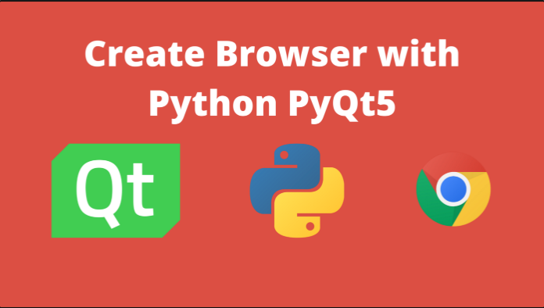.



Additionally, we’re taking advantage of the new ECMAScript 2015 (ES2015) support in Chakra, the JavaScript engine behind Microsoft Edge and the WebView control. ES2015 allows us to remove much of the scaffolding and boilerplate code, simplifying our implementation significantly. The following ES2015 features were used in the creation of this app: Array.from(), Array.prototype.find(), arrow functions, method properties, const, for-of, let, Map, Object.assign(), Promises, property shorthands, Proxies, spread operator, String.prototype.includes(), String.prototype.startsWith(), Symbols, template strings, and Unicode code point escapes.

**EXISTING SYSTEM**

1. Candy is a customized web browser which is similar to other

browsers like Mozilla Firefox, Google Chrome, Microsoft Edge etc.

with some differing functionalities.

1. It has Python for the backend part which is used to connect with the network so that whenever the user search for anything it will redirect it to the google search engine.
2. It has most visiting sites on the home page itself, which makes it more convenient for the user.

**USE OF THE PROJECT**

The main functions of ***Candy*** to fetch or retrieve informative resources from World Wide Web to the client/ user on demand, translate those files received from web server and display those content to the user and allow the client /user to access all other relevant resources & information via hyperlinks.

When the user inputs any URL (uniform resource locator) in the Candy, the user is navigated to that website by the browser quickly. Let us have a look on its processing. When user type any URL, for example https://msatechnosoft.in, the prefix of the URL decide how to retrieve it. The URL prefixes that the Candy is not able to handle directly is sent to related application. Like default email app is responsible to handle mailto: URL prefix. Following table gives an idea about some of the common URL prefixes:

**URL Prefix URL Interpretation**

**http:** Hypertext transfer protocol

**https:** Secured hypertext transfer protocol

**ftp:** File transfer protocol

**file:** Local file system

Candy is used to run the software application that allows retrieving, presenting and traversing the information from one place to another.  
  
- Candy provides the resources using the WWW (World Wide Web) this can be identified by URI (Uniform Resource Identifier).  
  
- Candy fetches the data like web page, image, video or other piece of content from the server and displays it accordingly.  
  
- Candy uses hyperlinks to display the resources and allow the users to navigate their browsers according to the resources.  
  
- Candy defines the application software that is designed for the user to access and retrieve the documents using the Internet.

**FEASIBILITY OF PROJECT**

***Candy*** is used to fetch or retrieve informative resources from World Wide Web to the client/ user on demand, translate those files received from web server and display those content to the user and allow the client /user to access all other relevant resources & information via hyperlinks.

Whenever the user provides the URL address in the address bar, it will redirect it to the google search engine and will provide optimal results and hence, it proves its conveniency.

**FUNCTIONAL SPECIFICATION**

There are several additional features implemented to make the browsing experience more pleasant:

* Keyboard shortcuts - press F11 to toggle fullscreen mode, ESC to exit fullscreen mode, or Ctrl + L to select the address bar
* CSS transitions for animating the menus
* Cache management
* Favorites management
* URL input analysis — “bing.com” navigates to http(s)://bing.com, “seahawks” searches Bing
* Auto-de/select the address bar on blur/focus
* Responsive design

The progress indicator, as well as the settings and favorites menus, leverage CSS transitions for animation. With the former menu, the temporary web data is cleared using the clearTemporaryWebDataAsync() method. With the latter menu, the list of favorites is stored on a JSON file in the root folder of the roaming app data store.

**SOFTWARE SPECIFICATION**

• Technology Implemented : Visual Studio Code, PYQt5 module

• Language Used : Python, HTML, CSS

• User Interface Design : HTML, CSS

• Candy : Web Browser

**HARDWARE REQUIREMENTS**

• Processor : intel processors

• Operating System : Windows

• RAM : 4GB minimum

• Hardware Devices : Desktop, Keyboard, Mouse

• Hard disk : 500 GB

**FUTURE SCOPE**

***Candy*** is used to fetch or retrieve informative resources from World Wide Web to the client/ user on demand, translate those files received from web server and display those content to the user and allow the client /user to access all other relevant resources & information via hyperlinks.

Since, it is a customized web browser, the client can modify or add the functionalities as per their conveniency like they can add voice searching, hand gesture controlling, lenses, etc.